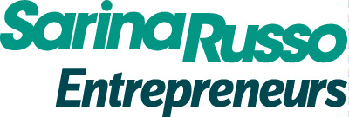

https://sarinarussoentrepreneurs.com.au
Business Development Diary

Full Name:
Contact Number:
Email Address:
*Please include details of all partners if setting up a partnership business.

How to Use this Document:
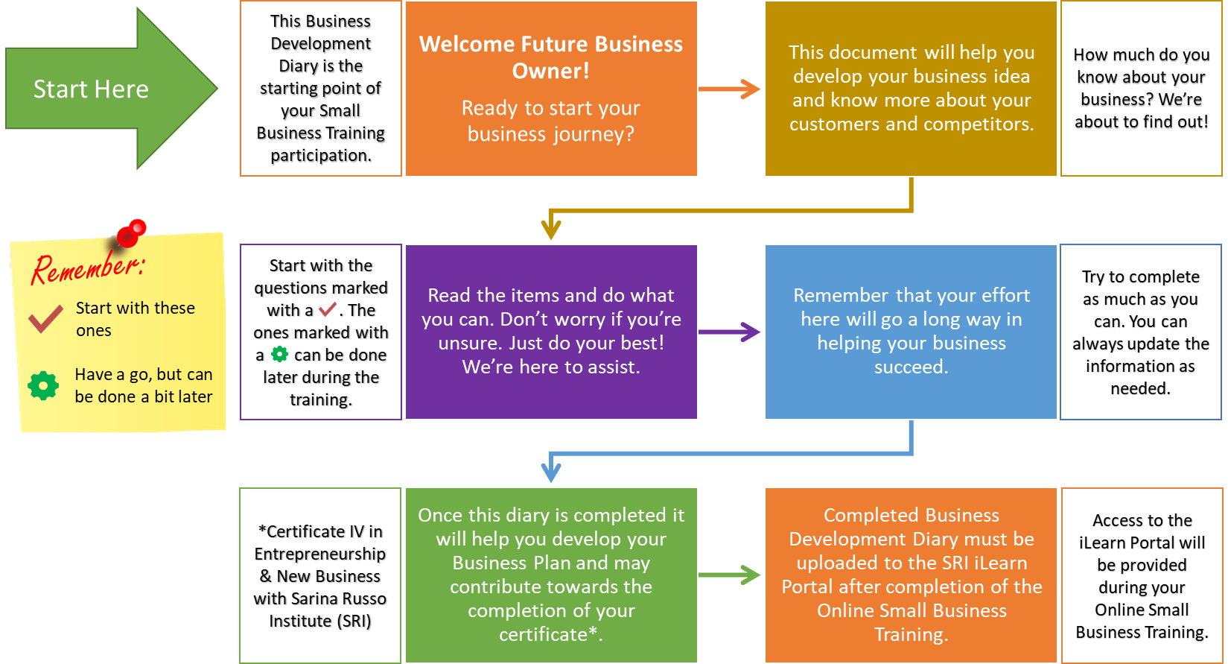
Proceed to the next page to begin…
- My Business Idea:
- Provide a summary of your business idea and how you came up with the idea.
The business is all about

I got my idea from

- Why do you think it’s a good business idea? Watch this: https://www.youtube.com/watch?v=8du-_71GigI
I believe it is a good idea because

- Why do you think your customers will buy from you? Watch this: https://youtu.be/m19f2ViLM9Q
Customers will choose my business because

- What are other business ideas have you thought about? Watch videos here:
https://www.youtube.com/results?search_query=Best+business+ideas

Other business ideas I have thought of include:

- About the Business:
My Business will be known as:
- You will need to register a business name if using a name other than your own legal name. Registration can be done through the following website: https://register.business.gov.au/registration/type. You will need your Tax File Number (TFN) and Australian Business Number (ABN) which you can also register for free through the same link. This can be done later on if you have not yet decided on your Business Name. You can check the updated costs here: https://asic.gov.au/for-business/payments-fees-and-invoices/asic-fees/asic-fee-indexation/
- I plan to operate it: (tick all applicable)
☐ | From Home
☐ | From a Rented Commercial Space
☐ | As a Mobile Business
☐ | In Markets
☐ | As an Online Business
☐ | Other (Please Specify):
- I plan to offer the following Products and/or Services:
List your products and services based on priority or importance to the business starting with most important. If you only have one product or service, that is OK. If you have more than 7 just list the top ranked products and/or services. Include your best estimates for pricing and costs.
The following are the Products and Services that will be offered to Customers: | I am planning to sell them for:  (A) | I think this is how much it will cost:  (B) | How much do you think you’ll make for every sale?  (A) – (B)
 | $ | $ | $

- I plan to fund my business startup through: (tick all applicable)

☐ | Personal Savings and/or Assets
☐ | Financial Assistance from Friends and Family
☐ | Investors
☐ | Bank Loan
☐ | Government Support
☐ | Grants
☐ | Sponsorships
☐ | Customer Deposits
☐ | Supplier Credit
☐ | Joint Venture
☐ | Crowd Sourcing
☐ | Other (Please Specify):

- Who will be My Customers?
Your ideal customer is called your Target Market. You can have more than one, and they can be direct consumers (people who use or consume your products and services), other businesses, or a combination of both. It is useful to focus on only one primary target market and a secondary market (if applicable) when you start your business to ensure you are providing sufficient attention to them without spreading yourself too thinly.
1. Based on your business idea, how would you describe your Target Market?
Take the time to think about and research your ideal customers and describe them. Provide as much detail as you can in the table below based on the factors that are important to your business. You do not need to fill in the details if the factor is not important to your business. Just remember, the more information you have about your customers, the better your chances that your business will succeed. So, make sure you’re clear about who you want as your customers and understand what their needs and preferences are. This process is called market segmentation. You can learn more about this by watching the video in the following link: https://www.youtube.com/watch?v=Q2ul83TSn2U

If Selling to Direct CONSUMERS:
CRITERIA | FACTOR | PRIMARY MARKET | SECONDARY MARKET
Demographic  How would you describe your ideal customer? | Age Group
 | Gender
Income Level /
Source of Income
Profession /
Level of Education
Geographic  Where are they? | Residence /  Location
Psychographic  What do they like? | Lifestyle
 | Hobbies
 | Brand Preferences
Behavioural  How do they behave? | How do they prefer to buy and pay?
 | How much and how often will they buy from you?
Specific Needs | What is their specific need that you are trying to address?

If Selling to OTHER BUSINESSES:
CRITERIA | FACTOR | PRIMARY MARKET | SECONDARY MARKET
Demographic  How would you describe your ideal customer? | Business Size:  Small/Medium/Large
Type of Businesses:
Retail/Café/Etc.
Estimated Budget for
Product/Service
Geographic  Where are they? | Location
Psychographic  What do they like? | Brand Preferences
 | Business Imaging
 | Existing Suppliers and Business Partners
Behavioural  How do they behave? | How do they prefer to buy and pay?
 | How much and how often will they buy from you?
Specific Needs | Their 2 Main Priorities:  Cost/Quality/Speed/Reliability/Etc.

- How do I find more information about My Customers?
Identifying what your customers want is one of the most important things to think about for your business. It is critical to accept that you cannot make everybody happy, so you should know who you want to focus your attention to. To find out this information, you need to do a bit of research.

To start with, interview people you know will be interested in your business and ask them some critical questions such as:
- What are you expecting from my product or service?
- How much will you be expecting to pay for it?
- What similar product or service are you using at the moment?
- Write down 5 questions important to your business and ask at least 3 potential customers. Fill out the table below with the questions and responses:
Watch some videos for examples: https://www.youtube.com/results?search_query=what+to+ask+your+customers

SURVEY QUESTIONS | RESPONSES

- Next, please do some online research about your products, services and customers in your area. List 3 websites you used as references below:

- Who am I competing with?
Identifying who your competitors are and what they offer is also very important for you to run a successful business. Who are providing the same or similar products as you at the moment in your selected area? Learn more about competitor analysis by watching this video: https://www.youtube.com/watch?v=5R_vYnQBfm4
- Identify 5 competitors and find out what customers like and dislike about them:
Competitor Name | Customers like them because: | The business is NOT the best at:

- How do I compare to My Competitors?
After identifying your competitors, evaluate how your proposed business will compare to them. We will now undergo a process called SWOT Analysis. You can watch the following video to learn more about SWOT Analysis: https://www.youtube.com/watch?v=9-NWhwskTO4
- List at least 3 things each that makes your business better or worse in designated boxes below:
My Business is BETTER in terms of: (STRENGTHS) | My Business is WORSE because of: (WEAKNESSES)

Looking at your STRENGTHS and WEAKNESSES, identify possible OPPORTUNITIES and THREATS for your business.
- List at least 3 things in each box below:
OPPORTUNITIES for My Business | THREATS to My Business

- How do I promote My Business?
For any business to succeed, you need to attract customers and convince them to choose your products and services over your competitors. But first, you need to find them and connect with them.
- Where can I find my customers?
Based on your information and results of your research, identify possible Physical and Online locations where you can find your customers and think about how you plan to reach them to introduce your product or service. Use the table below for this information:
Where can I find my customers? | What will I do to reach them?
- How can I convince my customers to support my business?
Once you’ve found your customers, your next task is to attract them to your business so they will want to buy what you are selling. This process is part of Marketing. What are some strategies that you are planning to do to promote your business? Watch some videos for inspiration: https://www.youtube.com/results?search_query=how+to+promote+your+business
Strategies that I plan to do to promote the business: | Estimated Cost:

- How will I operate My Business?
- My regular Trading Hours will be:
Days of Operation: | Time Business is Open: | Non – Operating Days:

- My products and services will be sold through:
Watch some videos for insights: https://www.youtube.com/results?search_query=distribution+channels
Distribution Channels:

- I will accept Payments using: Visit: https://business.gov.au/Finance/Payments-and-invoicing/How-to-choose-payment-methods
Payment Methods:

- The following will be potential Key Partners and Stakeholders for the business:
Research and list down your prospective suppliers, distributors and other key partners and Stakeholders for the business.
Watch: https://www.youtube.com/watch?v=ne26FlD2d6M
Suppliers / Distributors / Agents / Referrers / Consultants / Others: | What benefit do you get from them

I. The Legal Stuff:
- I will structure the Business as a:
For more information, please visit https://business.gov.au/planning/business-structures-and-types
☐ | Sole Trader | I am choosing this structure because…
☐ | Partnership (list names of all Business Partners):
☐ | Company
☐ | Trust

- My Business ABN is:
You will need an Australian Business Number (ABN) to run a business based on your business structure. ABN Registration is free and can be done through https://register.business.gov.au/registration/type

- I will need the following Licences and Permits to Run the Business:
Please go to https://ablis.business.gov.au and follow the prompts to identify the Licences and Permits that may be required for your business. List down only those identified as Licences and Permits in the table below. Make sure you send the results to your email address so you have a copy of the results. Explore https://business.gov.au or your relevant Industry Associations to find out any relevant qualification that may be required by your industry/business.
Licenses / Permits / Qualifications: | Details: (if available)

- I need to know the following information to effectively Establish and Run the Business:
Using the information you generated from https://ablis.business.gov.au, identify and list down any relevant Standards and/or Codes of Practice and briefly explain their importance to your business:
Standards / Codes of Practice: | Importance to Business:

- I have received Professional Advice from the following in regards to starting my business:
List down the Individuals and/or Organisations you have consulted and received Professional advice from in the table below:
Professional Advice Provided by:  (Name of Person or Organisation) | Nature of Professional Advice:
 | Legal Considerations of the Business
 | Financial and Taxation Information
 | Business Guidance

DECLARATION:
This document was accomplished and completed by:
Full Name: | Signature: | Date of Submission/Update:

